1. 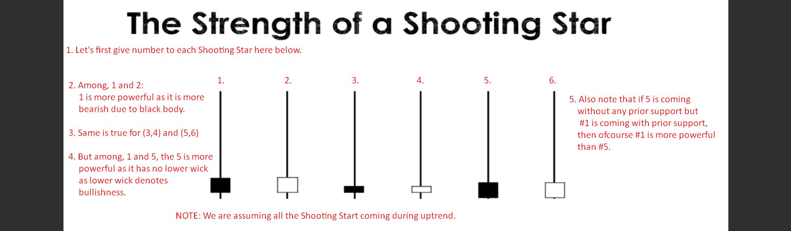
2. The following is weekly chart and we know that the higher is the timeframe, the higher is the probability that the trade will work in our favor.
3. 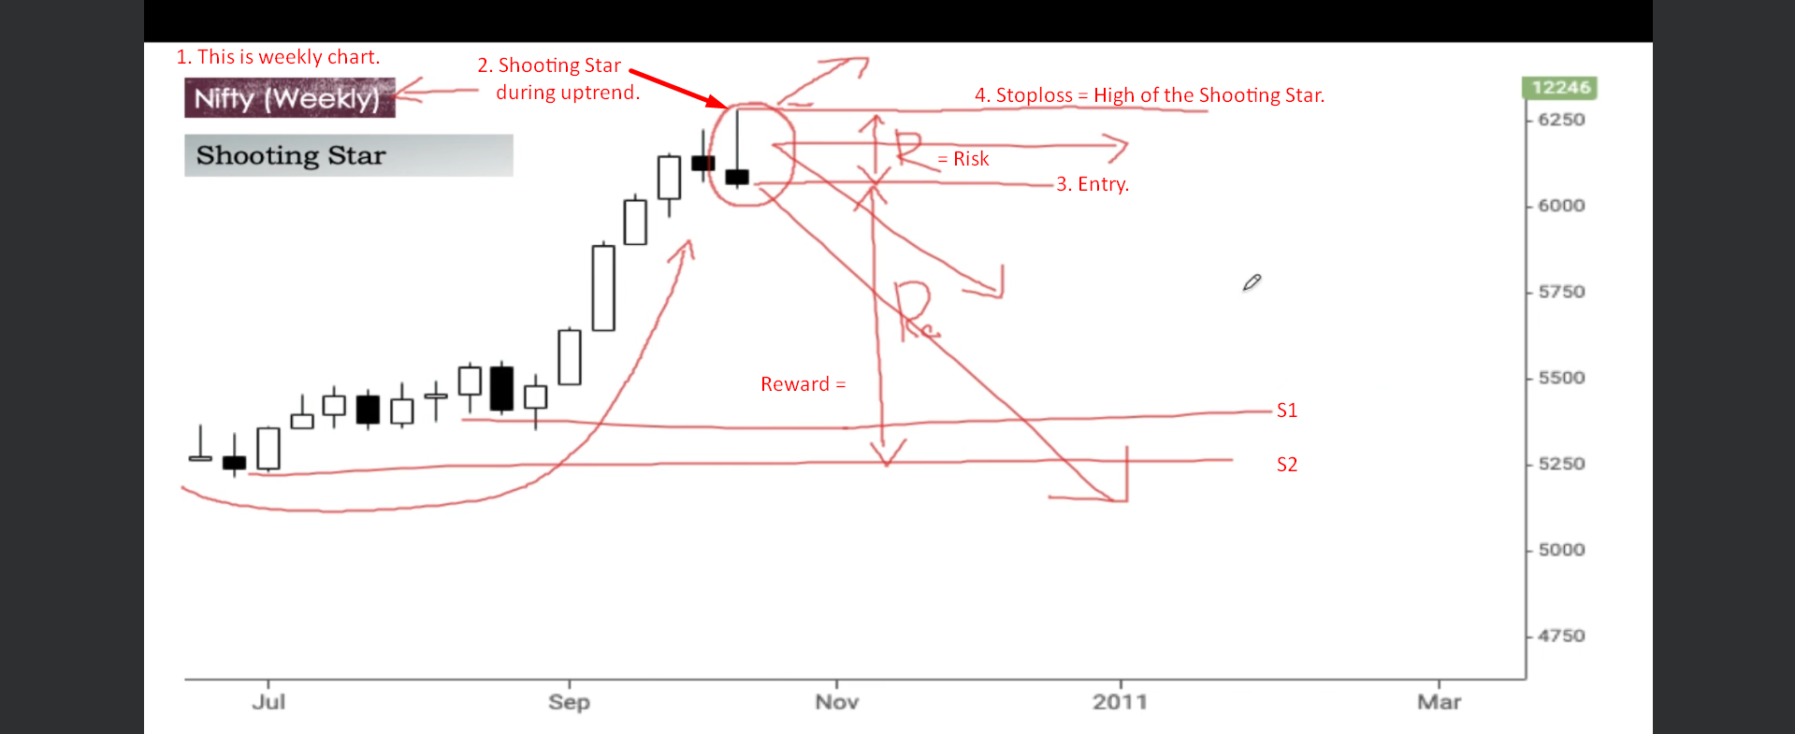  
   **NOTE**: If you are into options trading, then you know how we can use this there.
4. **NOTE**: Actually in the below slide, I must have said that it does not have prior resistance confirmation. 